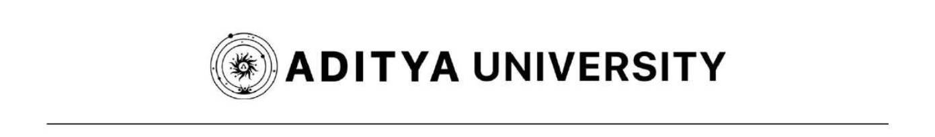

Biodata of the Supervisor

1. Name :

2. Designation :

3. Name of the Department :

4. Mail ID :

5. Mobile No. :

6. Nationality :

7. Religion :

8. Date of Birth :

9. Educational Qualification : (from UG onwards)
Latest passport size photo

S. No. | Qualification with Specialization | Percentage/CGPA | Month and Year of Pass | University/Institute

(Attach photostat copy of Ph.D. Original Degree)

10. Details of Doctoral Thesis
Area of Thesis work :

Title of Thesis :

Name of the University :

Year of award of Ph.D. :

11. Professional Experience :

S. No. | Institute / Organization | Position held | Date of Joining | Date of Relieving | Duration

12. Number of Publications :

S. No. | Category | During Ph.D. Program | After Ph.D. Program
1 | International Journals
2 | National Journals
3 | International Conferences
4 | National Conferences

13. (a) Research Publications (SCI/WoS/Scopus):

S. No. | Article details in IEEE format | Impact factor & H-index | Author Position

14. Research projects completed as Coordinator :

S. No. | Title of the project | Funding Agency | Sanctioned amount and year of sanction | Duration of the project | Present status

15. Research Experience :

a) Ph. D. scholars guided :

S. No. | Name of the Research Scholar | Title of the Thesis | Year of Award of Ph.D. | University /Institute which has awarded the Degree | Supervisor/  Co-Supervisor

b) Ph. D. scholars presently guiding :

S. No. | Name of the Research Scholar | Area of the work | Year of Registration | Registered  University /Institute | Supervisor/  Co-Supervisor

c) Details of the Book Chapters Published :

d) Details of the Text Books Authored :

e) Patents Published :

S. No. | Title of the Patent | Agency to which application is made | Year of application

f) Patents Granted :

S. No. | Title of the Patent | Agency to which application is made | Year of application

g) Publication Metrics :

Google Scholar | Scopus
h-index: | h-index:
i-10 index: | Citations:
Citations

16. Areas of research interests

:

17. Interested to supervise Full-Time Scholar (Yes/No) :

18. Other information (if any) :

Declaration

I hereby declare that the information furnished is true to the best of my knowledge and belief.

Signature

Date:

Station:

